# 

# Timeline

**Project Progress And Planning**

---Fifteen_Go

GROUP 15

### Front-and-back timeline time-specific presentation

### 1.The First Iteration

* From the second week to the end of the fifth week, the first iteration was completed with the following timeline: (planning, risk analysis, implementation engineering, customer assessment)
* **2-25 Second week**
* **Develop plans: risk Analysis**
* 2019 / 2 / 27 completion of business logic preliminary analysis ( Dong version 1)

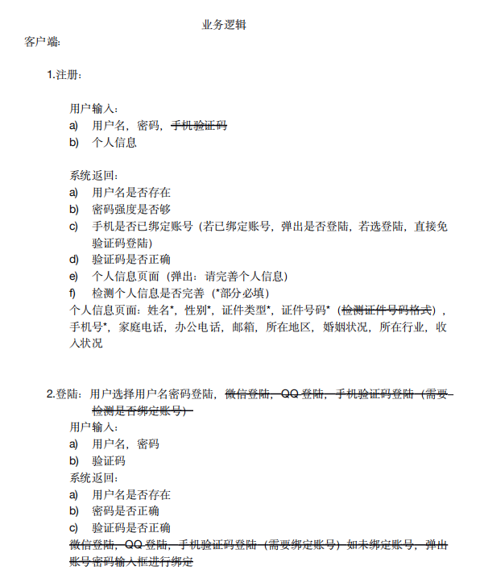

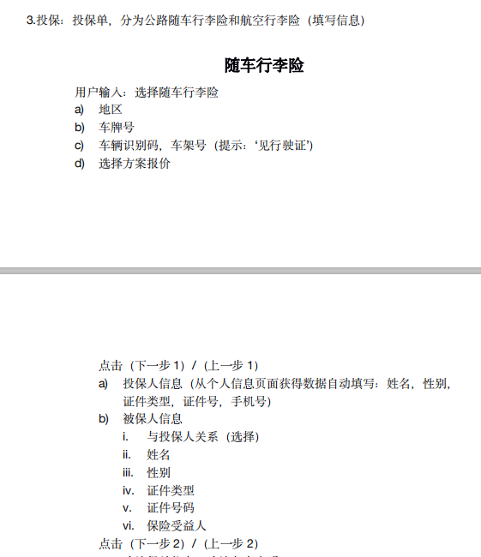

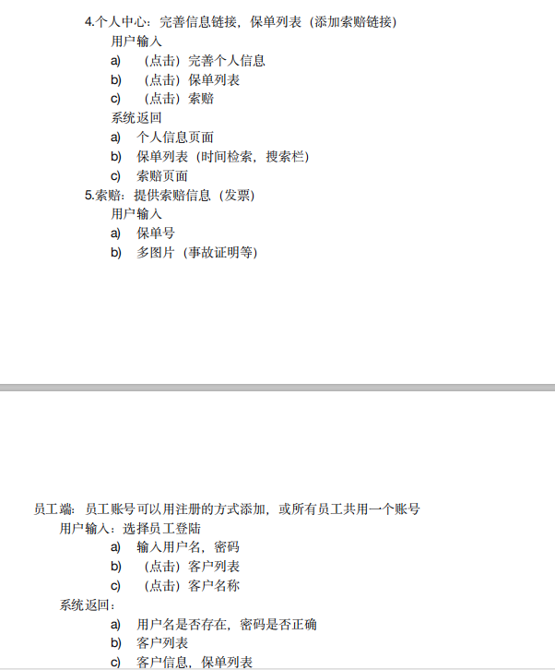

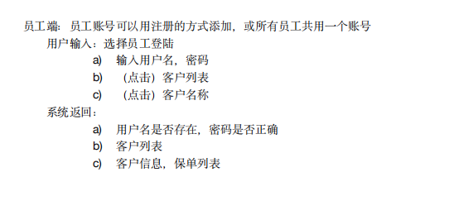

* 2019 / 2 / 28 complete plan formulation, package,Gantt



* 2019 / 3 / 3 completion of risk analysis

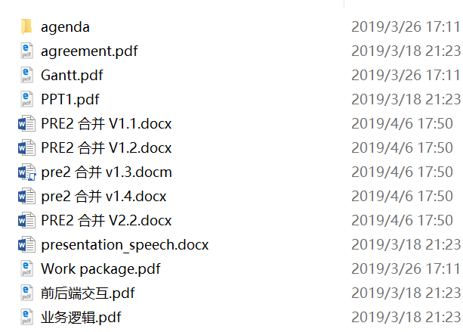

* 2019 / 3 / 4 third week and 2019 / 3 / 11 Fourth week
* 2019 / 3 / 4 to implement the installation of front-end development environment, such as Nodejs , Npm ; installation and debugging of back-end development tools such as maven,mysql
* 2019 / 3 / 7 framework; Design of database tables

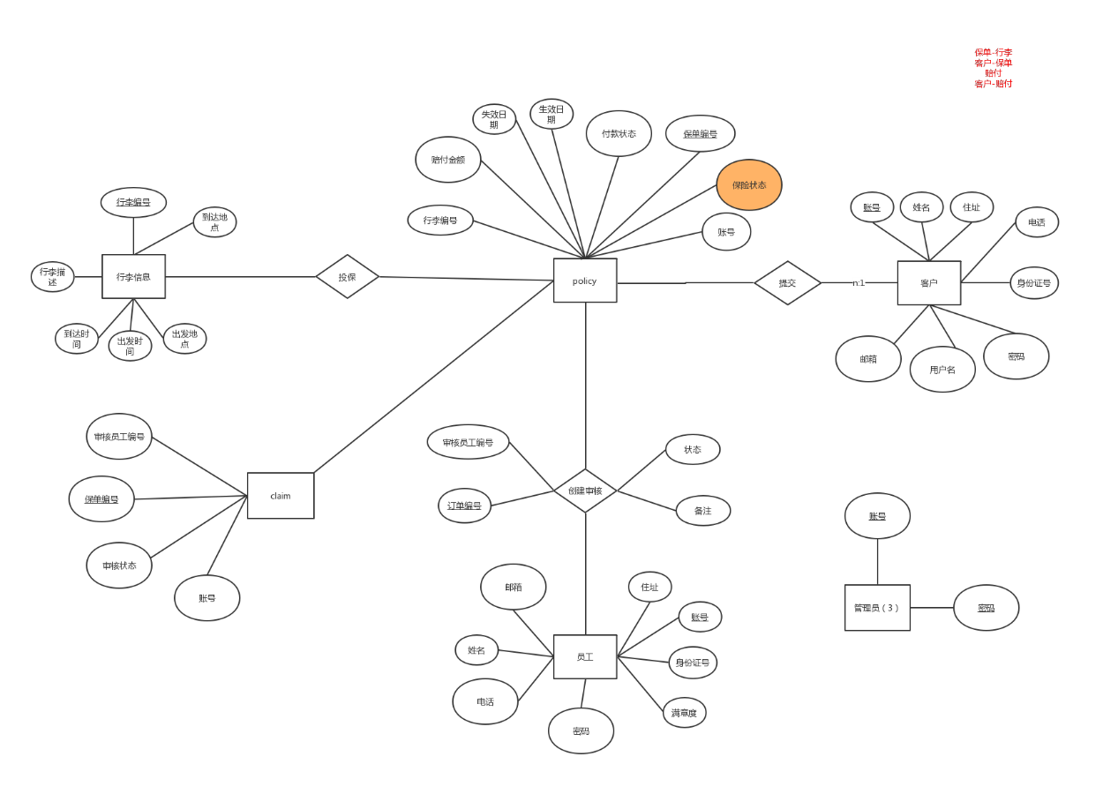

* 2019 / 3 / 11 Vue Grammar Learning, spring boot related Learning

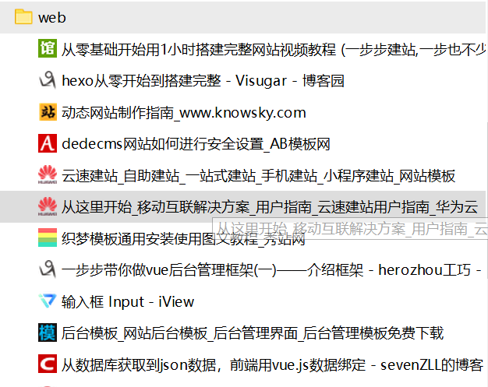

* 2019 / 3 / 18 the fifth week
* implementation: customer Assessment
* 2019 / 3 / 18 completion of the web Home Page (initial edition);

（初版首页图）

* implementation of the database;

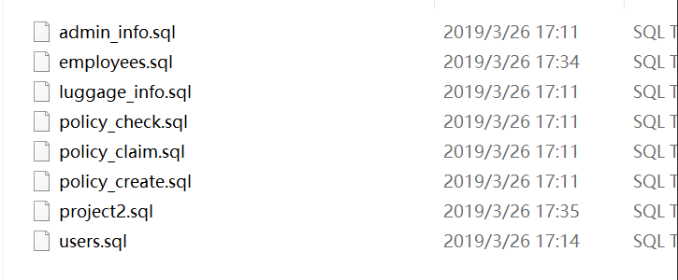

* 3-19 完成 登陆页面（初版）
* 3-22 完成 注册页，表单页，员工表单 的表格制作（初版）
* 3-24 完成About Me制作（初版）
* 3-25 完成用户评估

（自己翻译一下插入截图哈哈哈 我太累了）

（底下还差一个董乐辉的表单图 也注明红字了）

### 2.The Second Iteration

* **By the end of the sixth to eighth weeks, the second iteration plan will be completed:**
* **2019 / 3 / 25:the sixth week**
* **Plan for** **the sixth week and risk analysis**
* 2019 / 3.26 preliminary analysis of business logic
* adjustment of database structure and table content;

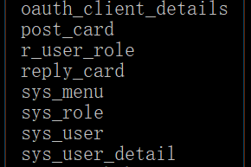

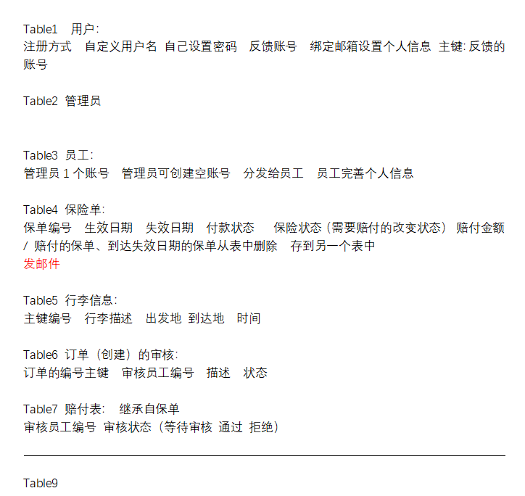

* 2019 / 3.27 Front-end Interactive Design (Dong Le-hui Edition)

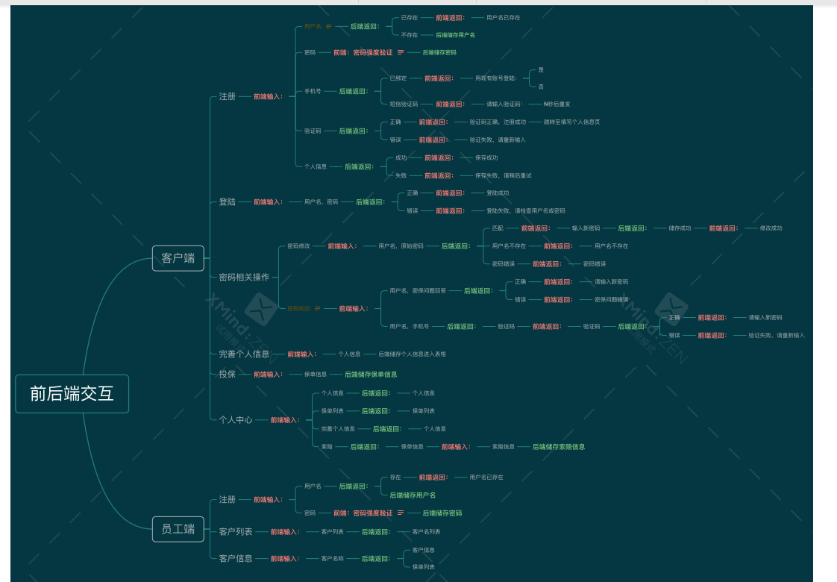

* 2019 / 3.28 risk Assessment
* **2019 / 4 / 1; the seventh week**
* **implementation of the work in** **the seventh week of** **2019 / 4 / 1;**
* 2019 / 4 / 2 complete the landing page (version 2)

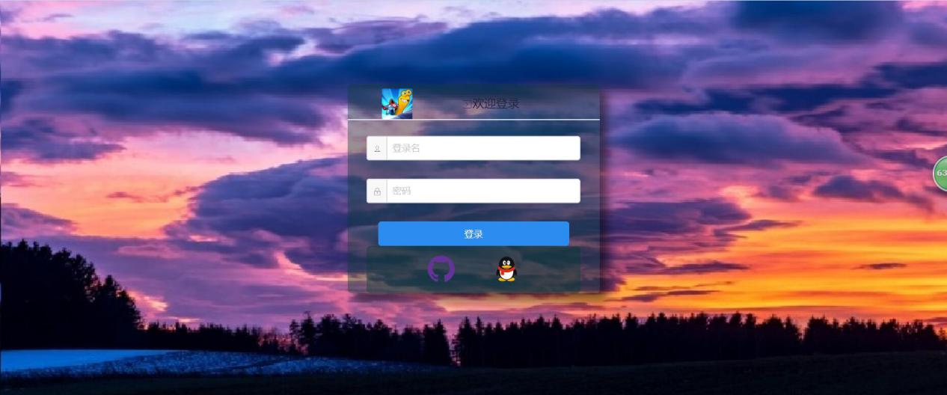

* 2019 / 4 / 3 complete the login page (version 3)



* 2019 / 4 / 3 complete the web home page (version 2)



* 2019 / 4 / 5 complete the form page. (version 2)

**（董乐辉端表单）**

* 2019 / 4 / 5 form making of employee form (version 2)

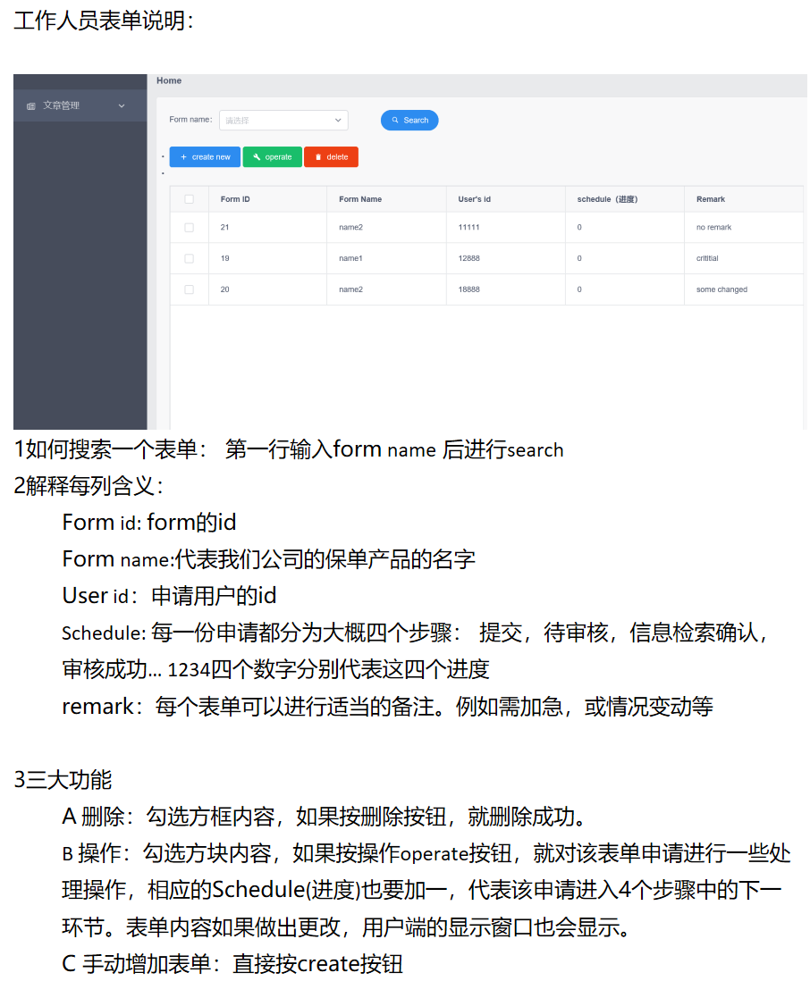

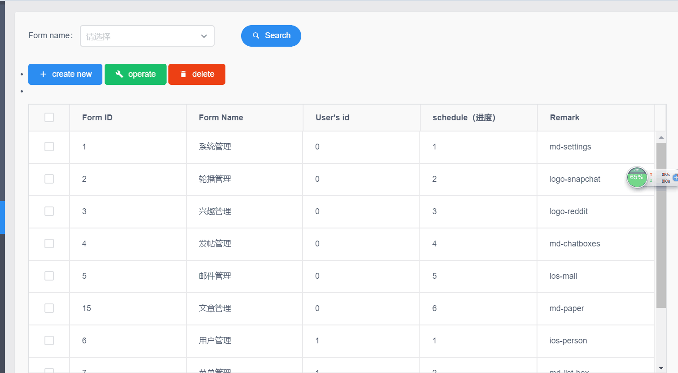

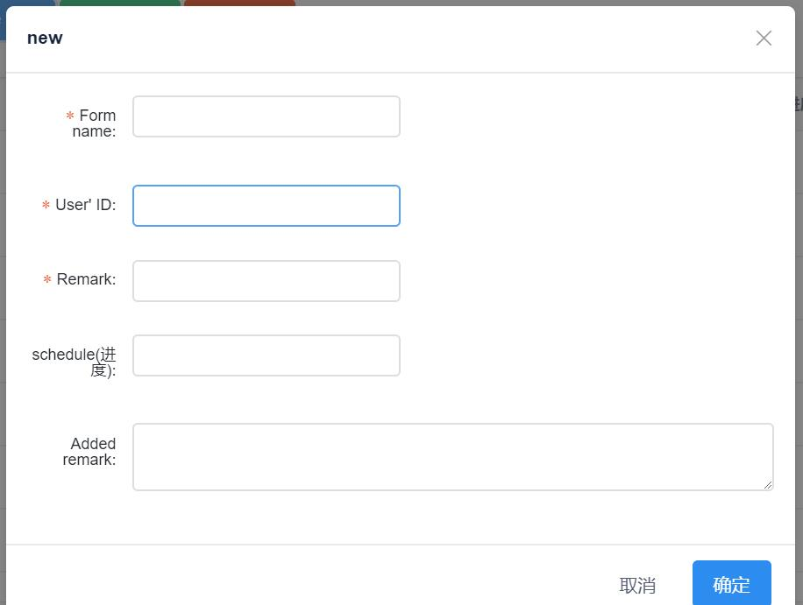

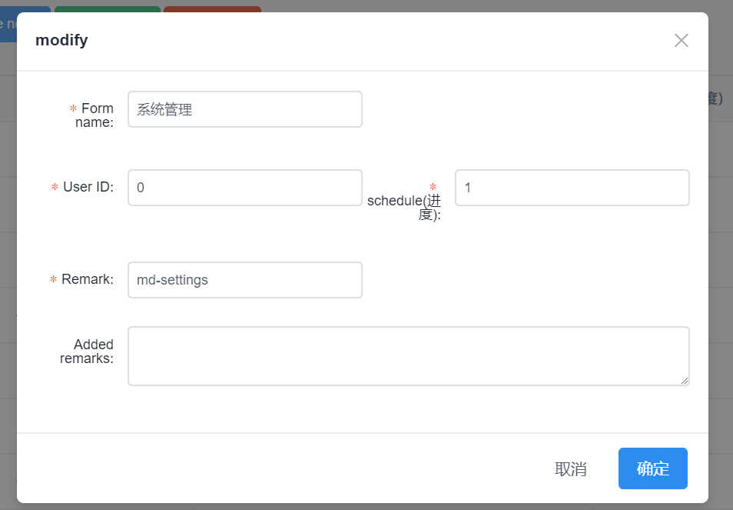

* **In 2019 / 4 / 8 week 8;**
* **implementation works:**
* front-end data encapsulation is planned in 2019 / 4 / 8;
* back-end data transmission logic is planned in 2019 / 4 / 9;
* It is planned to complete the front-end program test in 2019-4-12
* the rear-end docking in 2019-4-14.
* The Third Iteration
* **From the ninth to the twelfth week of** **the third iteration, the final iteration will be completed, as follows:**
* **Week 9 2019 / 4 / 15;**
* It is planned to complete user authentication, user authorization and protected page redirection (version 3) in 2019 / 4 / 17
* user comment question function in 2019 / 4 / 19;
* It is planned to complete the employee-side inquiry, modification, and deletion of insurance policies in 2019 / 4 / 21.
* **Week 10, 2019 / 4 / 22.**
* plans to complete the bilingual feature by 2019 / 4 / 25;
* plans to complete the login function through the QQ and github third-party platforms by 2019 / 4 / 27;
* plans to complete the testing of the new functionality by 2019 / 4 / 28;
* **week 11 for 2019 / 4 / 29.**
* plans to implement mobile-side adaptation in 2019 / 5 / 1;
* plans to complete and test mobile-side adaptation in 2019 / 5 / 4;
* plans to host applications on cloud servers in 2019 / 5 / 5;
* **2019 / 5 / 6 weeks 12.**
* plan to complete the full functionality of the page testing and delivery in 2019 / 5 / 6;